

Seafarers Health Directive- (Annex-5) Seafarers Periodic Medical Examination Form

……………………………Center

SEAFARER’S
Name Surname
Sex (Male / Female)
ID Number/ Pass Number Date of birth (day/month/year) Nationality
Place of birth Department
Telephone number
e-mail


Sight

:
:
:
:
:
:
:
:
:

Use of glasses or contact lenses
Visual acuity
No Yes
if yes, specify which type and for what purpose .....................................................

 | Unaided |  |  | Aided
 | Right eye | Left Eye | Binocular | Right eye | Left Eye | Binocular
Distant
Near
Visual fields
 | Normal | Defective
Right eye
Left Eye

Colour vision | Normal | Defective
Passed colour vision test in accordance with CIE-143-2001 standards:
Ishihara Test Other PIC Anomaloscope Farnsworth D 15 Other ................ Date of last passed colour vision test …...../………./……………

Hearing
Audiometry | 500 Hz | 1'000 Hz | 2'000 Hz | 3'000 Hz | Pure tone average(threshold values in dB)
Right ear
Left ear
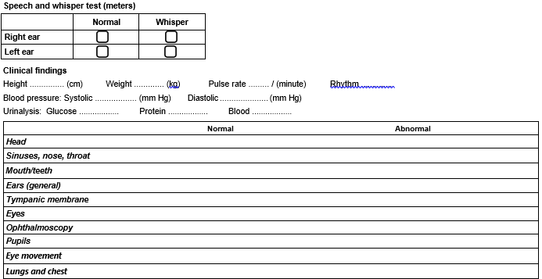
Unaided Aided

Breast examination
Heart
Skin
Varicose veins
Vascular (inc. pedal pulses)
Abdomen and viscera
Hernia
Anus (not rectal exam)
G-U system
Upper and lower extremities
Spine (C/S, T/S and L/S)
Neurologic (full/brief)
Psychiatric
General appearance

Chest X-ray

Not performed | Performed on (day/month/year) ........./........./.............
Results
Other diagnostic test(s) and result(s)

 | Test : Result
1 | FBG
2 | CBC
3 | AST
4 | ALT
5 | Anti-HBs
6 | HBsAg
7 | Anti-HCV
8 | Anti-HIV
9 | UA
10
Medical practitioner’s comments and assessment of fitness, with reasons for any limitations:

Assessment of fitness for service at sea
On the basis of the examinee’s personal declaration, my clinical examination and the diagnostic test results recorded above, I declare the examinee medically:
Fit for look-out duty
Not fit for look-out duty
Deck service Engine service Catering service Other services
Fit Unfit
Without restrictions
With restrictions
Visual aid required Yes
No
Describe restrictions (e.g., specific position, type of ship, trade area) :
Medical certificate’s date of expiration (day/month/year): ........./......... /............
Date medical certificate issued (day/month/year): ........./......... /............ Number of medical certificate:
Signature of medical practitioner:
Medical practitioner information (name, license number, address):

